***Templates Why Do We Need Templates***





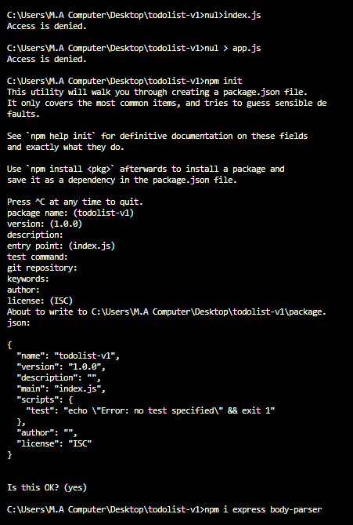

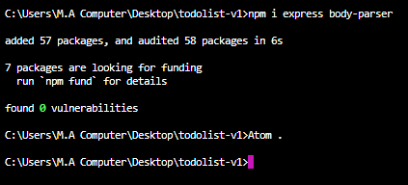

<https://developer.mozilla.org/en-US/docs/Web/JavaScript/Reference/Global_Objects/Date/getDay>

const birthday = new Date('August 19, 1975 23:15:30');

const day1 = birthday.getDay();

// Sunday - Saturday : 0 - 6

console.log(day1);

// expected output: 2

# [What is the difference between res.send and res.write in express?](https://stackoverflow.com/questions/44692048/what-is-the-difference-between-res-send-and-res-write-in-express)

<https://stackoverflow.com/questions/44692048/what-is-the-difference-between-res-send-and-res-write-in-express>

**Code:**

**Index.html:**

<!DOCTYPE html>

<html lang="en" dir="ltr">

<head>

<meta charset="utf-8">

<title>To Do List</title>

</head>

<body>

<h1>It's a weekday.</h1>

<p>Why are you not working.</p>

</body>

</html>

**App.js:**

//jshint esversion : 6

const express = require("express");

const bodyParser = require("body-parser");

const app = express();

app.get("/",function(req, res){

//res.send("Hello!");

//var a = 3+5;

//res.send(a);

var today = new Date();

var currentDay = today.getDay();

if (today.getDay()===6||today.getDay()===0) {

res.write("<h1>Yay it's the weekend!</h1>")

}else {

//res.write("<p>It is not weekend.</p>")

//res.write("<h1>Boo! I have to work!</h1>");

res.sendFile(__dirname+"/index.html");

}

//res.send();

});

app.listen(3000,function(){

console.log("Server started on port 3000.");

});